**HTML Images Map**

**Image Maps:**

***Write Definition here!***

In short, we can set many links by creating 1 or more clickable areas in different parts of 1 single image.

This is called ***Image Map***.

***OR***

With HTML image maps, we can create clickable areas on an image.

An image map is an image with clickable areas.

**Syntax:**

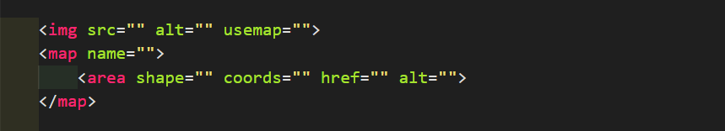

**Representation:**

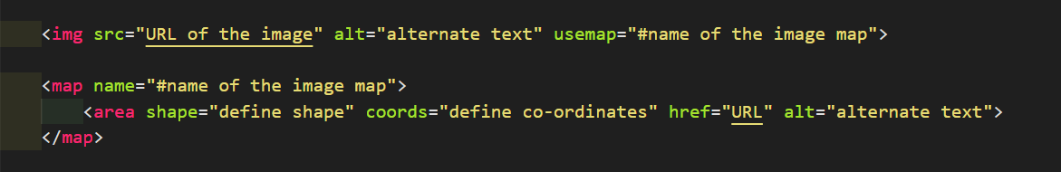

***Note:*** In the above picture # will included in name attribute of map element, but name value is the same in usemap and name attribute.

But if we write ***#*** with name then it will work.

**Code:**

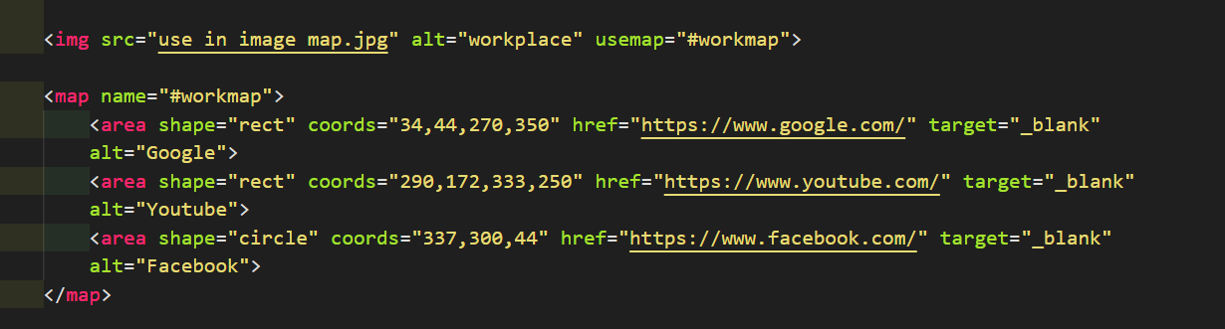

**Example:**

It is the output, try to click on the computer, phone, or the cup of coffee in the output of your browser:

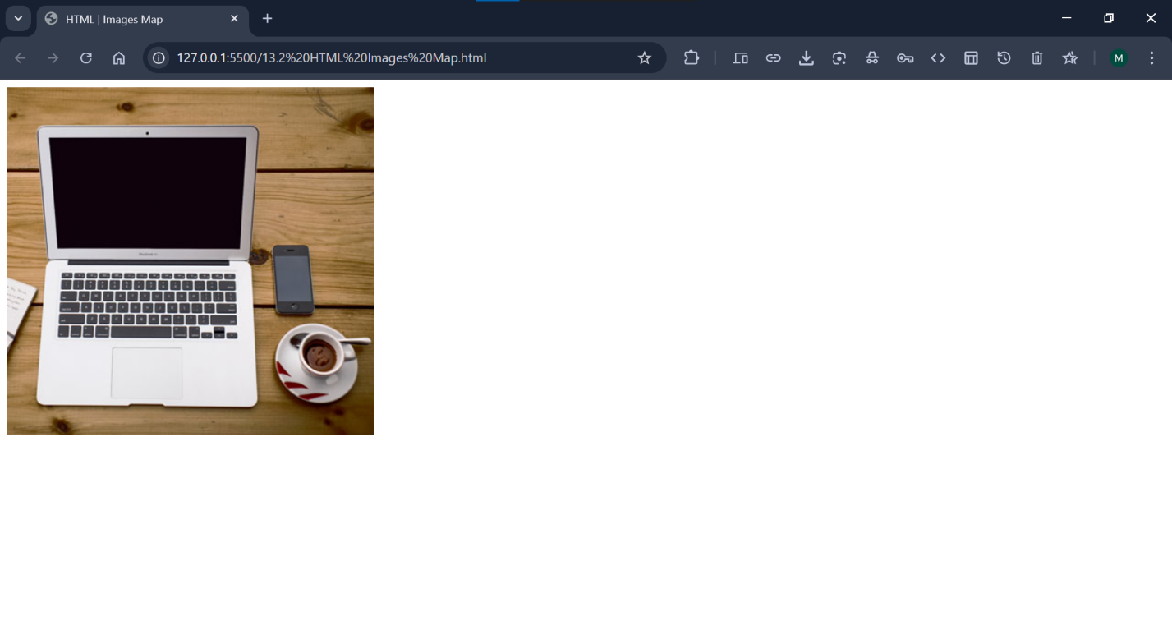

**How Does it Work?**

The idea behind an image map is that we should be able to perform different actions depending on where we click on the image.

To create an image map you need an image, and some HTML code that describes the clickable areas.

**Tags & Attributes Used in Image Map:**

There are 3 tags and 5 attributes used to create an image map:

1. <img> – tag
2. <map> – tag
3. <area> – tag
4. usemap – attribute (used in img tag)
5. name – attribute (used in map tag)
6. shape – attribute (used in area tag)
7. coords – attribute (used in area tag)
8. href – attribute (used in area tag)

The HTML <img> tag defines the main image in HTML document in which link will create in different parts of it.

The HTML <map> tag defines an image map.

The HTML <area> tag defines one or more areas to clickable in image.

The ***usemap*** attribute is used to create a relationship between the image and the image map. The ***usemap*** value starts with a hash tag ***#*** followed by the ***name of the image map***.

Define what is the work of name, shape, coords and href attribute in image map like above.

The name attribute is used to create a relationship between ***usemap*** and ***name*** attribute.

The shape attribute is used to create the shape of the clickable areas.

The cords attribute is used to create the co-ordinates of the shape of clickable areas.

The href attribute is used to specify the link of the page where we go to when we click on those clickable areas.

**Embed The Image:**

The image is embedded using the <img> tag in the HTML document.

The only difference from other images is that we must add a ***usemap*** attribute in it.

The ***usemap*** attribute is used to create a relationship between the image and the image map. The ***usemap*** value starts with a hash tag ***#*** followed by the ***name of the image map***.

***Tip:*** You can use any image as an image map!

**Code:**



**Output:**

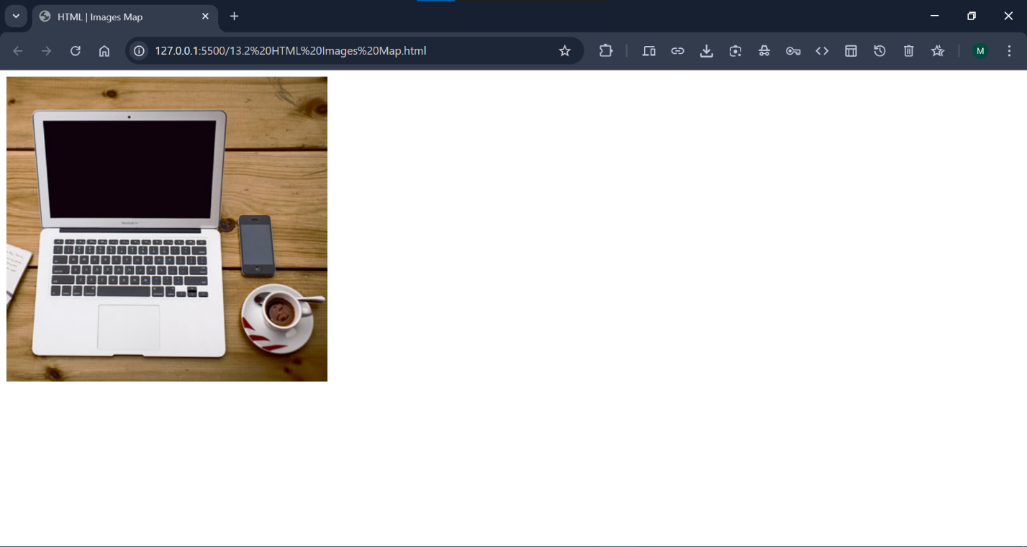

**Create Image Map:**

Then, add a <map> element after the ***<img>*** tag.

The ***<map>*** element defines an ***image map*** in HTML document.

The <map> element is used to create an ***image map***.

The <map> element is linked to the image by using the required ***name*** attribute.

The name attribute must have the same value as the <img>'s ***usemap*** attribute.

**Code:**



**Output:**

***The output will remain show the same as above!***

**Create an Area:**

Then, add the clickable areas using ***<area>*** tag inside the ***<map>*** element.

A ***clickable area*** is defined in the image using an ***<area>*** element.

We can define many clickable areas in 1 image using <area> tag.

**Syntax:**

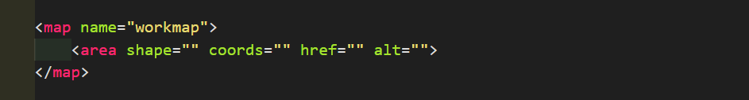

**Define The Shape & Co-ordinates for Area:**

We must define the shape and some coordinates of the clickable area to be able to place the clickable areas onto the image.

**Shapes/Values of Area Tag:**

There are 4 values of area tag:

* rect - defines a rectangular region
* circle - defines a circular region
* poly - defines a polygonal region
* default - defines the entire region

Now, create the clickable areas on laptop, mobile phone and cup of coffee with plate.

**Create Clickable Areas in Laptop:**

To create clickable areas in ***laptop part*** of the main image we need to define the rectangle shape in the area tag.

**Code:**

***Define the rectangle shape for the laptop part on main image using shape attribute:***

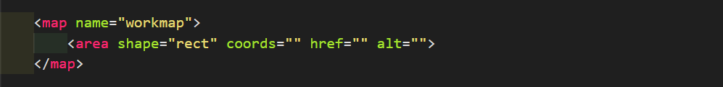

**Output:**

***The output will remain the same as above!***

**Define Co-ordinates for Rectangle Shape:**

***Define the area (co-ordinates) for rectangle shape in the laptop part on complete image using coords attribute:***

The co-ordinates use pixels from the left margin on x-axis and pixels from the top margin on y-axis of the shape of image map.

Co-ordinates come in 2 pairs, 1 margin value of x-axis and 1 margin value of y-axis defines in 1 pair. That means we need to define total 4 margin values of co-ordinates of any shape for the image map.

OR

We need to define 4 co-ordinate values of any HTML element, means (2 values of x-axis and 2 values of y-axis) of any shapes of area.

We can define the co-ordinates of area by giving values of left and top pixels to any HTML element.

**Code:**

***Define the first 2 co-ordinates of area of rectangle shape:***

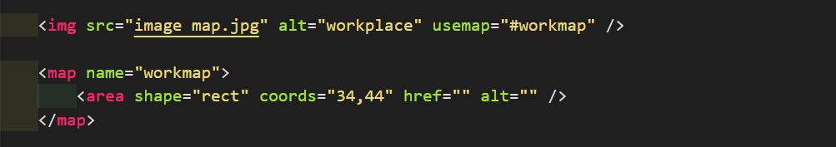

**Explanation:**

The coordinates for shape="rect" come in pairs, one for the x-axis and one for the y-axis.

The coordinates 34,44 is located 34 pixels from the left margin and 44 pixels from the top margin.

***Representation of the above explanation:***

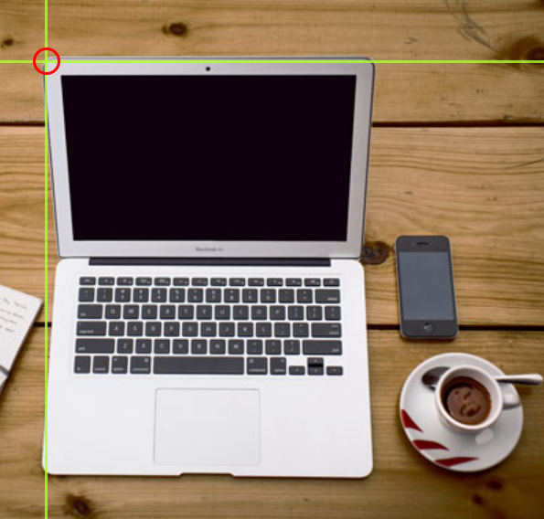

**Code:**

***Define the second 2 co-ordinates of area of rectangle shape:***

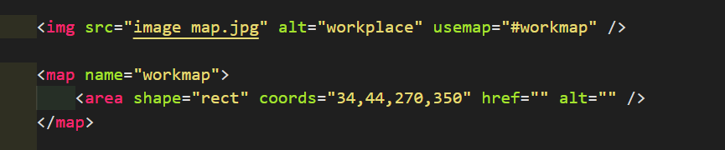

**Explanation:**

The coordinates 270,350 is located 270 pixels from the left margin and 350 pixels from the top.

***Representation of the above explanation:***

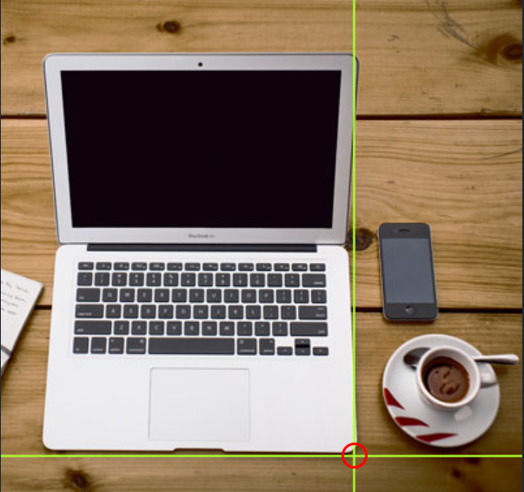

**Output:**

***The output will remain the same as above but you can see the black border around the laptop if you click and hold on it, it means our clickable area have been created!***

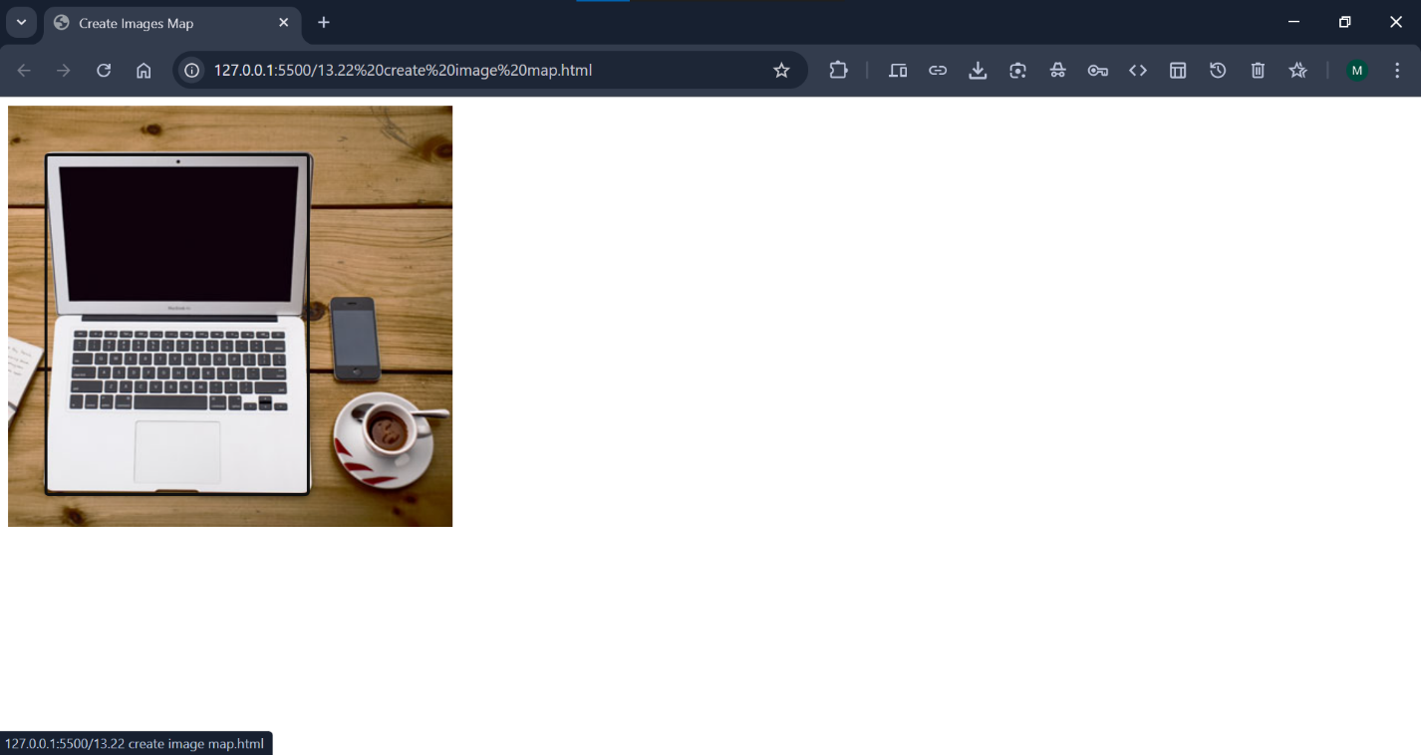

Now we have enough data to create a clickable rectangular area.

**Specify the Link:**

Then we need to specify the link in href attribute.

What happen when we click on that rectangular area on image, for this we must specify the link in href attribute.

**Code:**

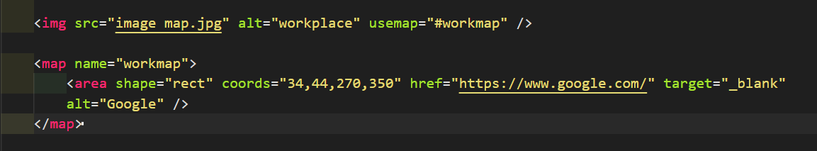

**Representation of the Image:**

***The representation of the image like this after specify the link:***



**Output:**

***If we click only on the rectangular area shape like above in the whole image, then we will google will open, otherwise if we click anywhere on the image then nothing happens!***

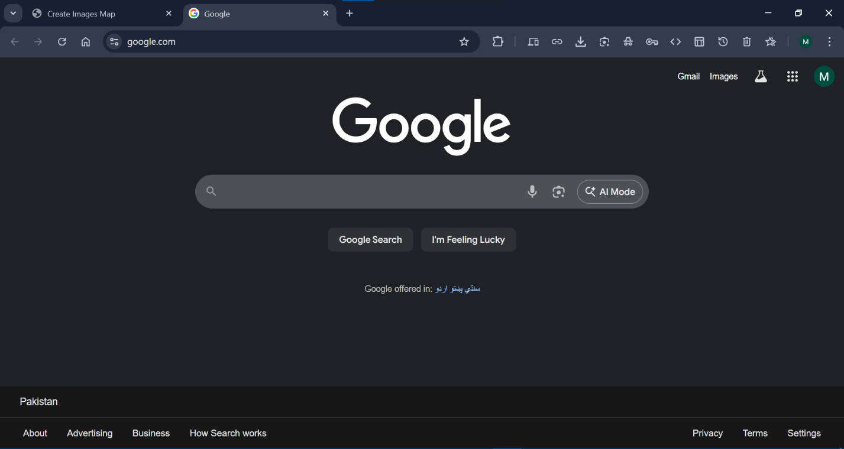

***Create the clickable areas on mobile phone and cup of coffee with plate like above:***

For this, we need to write area tag for cup of coffee with plate to create clickable areas on the image like above.

**Create Clickable Areas in Cup of Coffee:**

To create clickable areas in “***Cup of Coffee with Plate***” part of the main image we need to define the circle shape in the area tag.

Add an area tag below the “***first area tag***” in the same map element.

**Code:**

***Define the circle shape for the cup of coffee part on main image using shape attribute:***

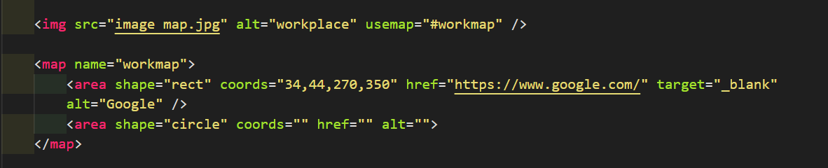

**Output:**

***The output will remain the same nothing happens right now!***

**Define Co-ordinates for Circle Shape:**

***Define the area (co-ordinates) for circle shape in the cup of coffee part on complete image using coords attribute:***

The syntax to write co-ordinates for the shape circle is:

**Syntax:**



To add a circle area, first locate the coordinates of the center of the circle.

The coordinates of the center of the circle are 337, 300.

**Code:**

***Define the co-ordinates of center of circle:***

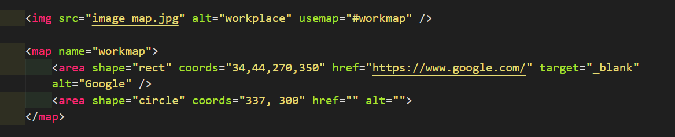

**Representation:**

***Image of the representation of the co-ordinates of center of circle:***

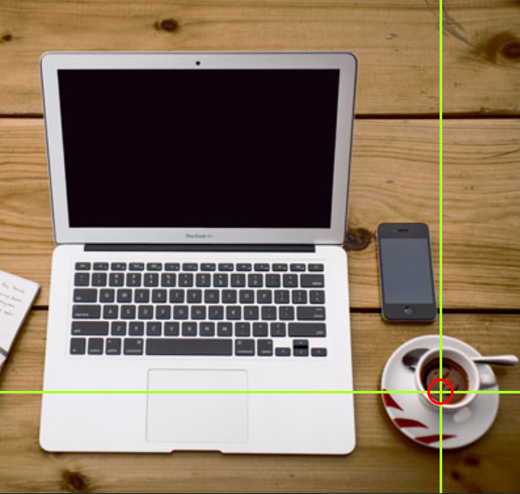

**Output:**

***The output will remain the same nothing happens right now!***

**Define Radius of Shape Circle:**

Then specify the radius of the circle.

The radius of the circle is 44 pixels.

**Code:**

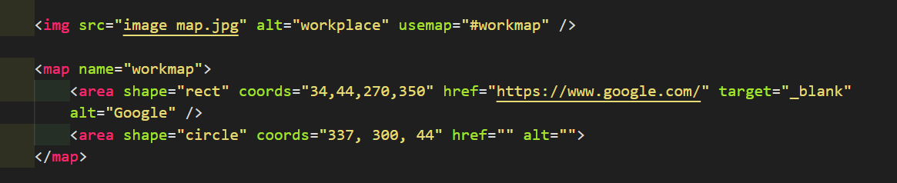

**Representation:**



**Output:**

***The output will remain the same!***

Now we have enough data to create a clickable circular area.

This is the area that becomes clickable and will send the user to the page that we will specify the link in href attribute.

**Specify The Link:**

Then we need to specify the link in clickable area in the circle shape in href attribute.

**Code:**

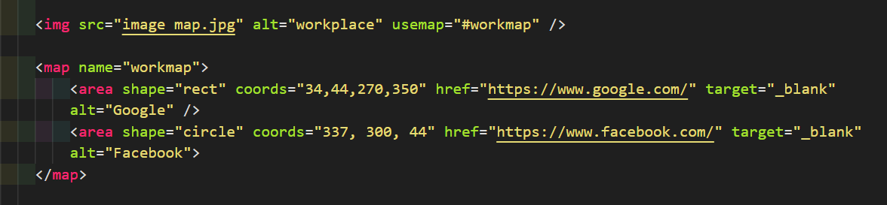

**Representation:**

***After specify the link, the representation of the image like this:***



**Output:**

***When we click on the circle (cup of coffee with plate) in the main image, then Facebook will open:***



***Create the clickable areas on mobile phone like above:***

For this, we need to write area tag for mobile phone to create clickable areas on the image like above.

**Create Clickable Areas on Mobile Phone:**

To create clickable areas on “***Mobile Phone***” part of the main image we need to define the rectangleshape ***(rect)*** in the area tag.

Add an area tag below the “***second area tag***” in the same map element.

**Code:**

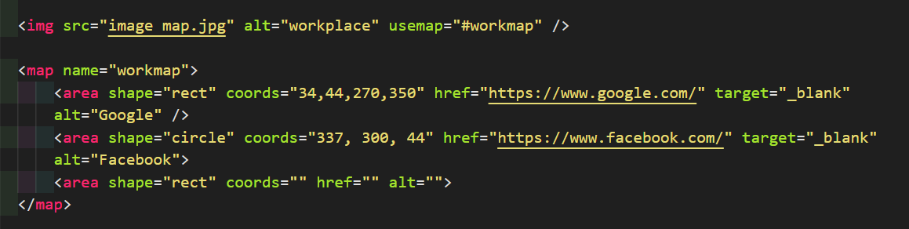

**Output:**

***The output will remain the same nothing happens right now!***

**Define Co-ordinates for Rectangle Shape:**

These are the coords of rect shape: 290,172,333,250

**Code:**

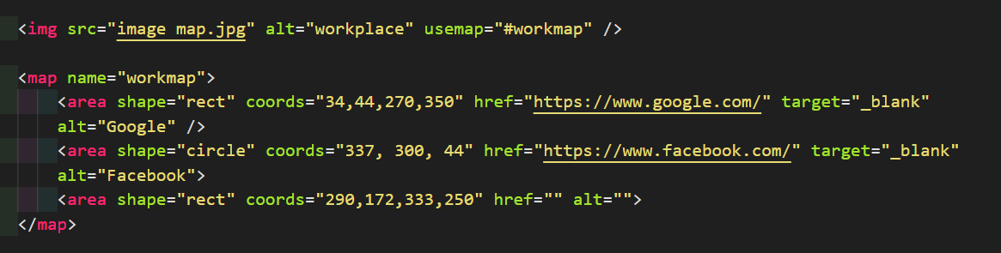

**Output:**

***The output will remain the same nothing happens right now!***

**Specify The Link:**

Then we need to specify the link in clickable area in the rectangle shape in href attribute.

**Code:**

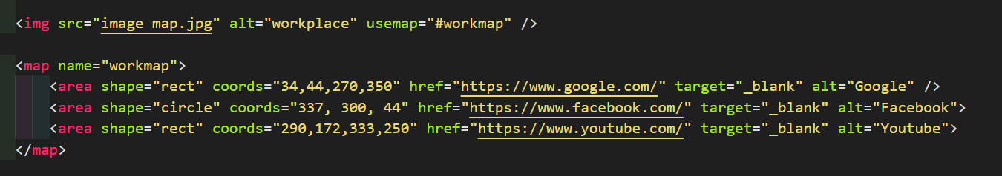

**Output:**

***Output is like this, when we click on mobile phone then YouTube will open in new tab:***

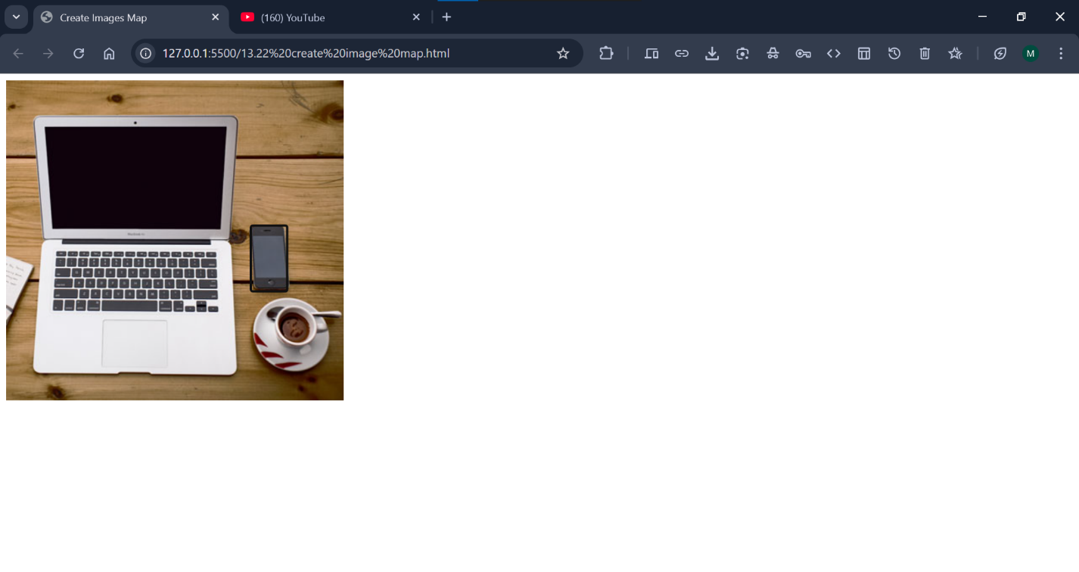

**The Poly Shape:**

The shape="poly" contains several coordinate points, which creates a shape formed with straight lines (a polygon).

This can be used to create any shape.

Like maybe a croissant shape!

How can we make the croissant in the image below become a clickable link?

**Code:**

***Define the Polygonal*** ***shape for the Mobile Phone part on main image using shape attribute:***

**Output:**

***The output will remain the same nothing happens right now!***

**Chapter Summary:**

1. Use the HTML <map> element to define an image map
2. Use the HTML <area> element to define the clickable areas in the image map
3. Use the HTML usemap attribute of the <img> element to point to an image map

**HTML Image Tags:**

***Image present here!***